Dear Local Business,

Feed Me Bellarine – No Questions, No Agendas
Feed Me Bellarine is a local Bellarine Peninsula community group which has been set up to help people & families in need, by using good quality left-over food and excess produce to make healthy, hot dinners and meals to feed the community. Feed Me Bellarine has an ethos they stand by - “No Questions, No Agenda’s” - anyone living on the Bellarine Peninsula who is vulnerable or needing help will be looked after.
Founded by Lana Purcell from Bellarine Catering and Belly Bowls and local chef Anthony Woodbury, Feed Me Bellarine is currently feeding approximately 50 families every week through private homes to the Kinship carers and providing over 250 hot meals every week and delivering these around the Bellarine Peninsula. Lana and Anthony are currently doing this by saving food waste and produce from their commercial kitchens and preparing ready to eat meals.
Word is spreading about Feed Me Bellarine through stories in the local newspapers and posts on social media, and many local businesses and community members are wanting to know how they can help. Rolling Pin have been providing left over bakery items daily and IGA Barwon Heads have provided bulk eggs, this is just an example of the wonderful support Feed Me Bellarine is already receiving.
Lana & Anthony are hoping that other like-minded businesses will come on board and contribute by way of donating left-over food, dairy, fresh produce etc, and potentially also preparing meals with their excess food & produce. They are also seeking money donations so they can buy much needed supplies and stock pantry items. A lovely member of the community has donated a vintage caravan which can be used to serve meals from, which requires renovating, so any money raised will be gratefully accepted and used wisely.
If you are a business that often has food leftovers & excess produce available that you could donate to Feed Me Bellarine, we would love to hear from you. Or perhaps you can contribute in another way?
Please feel free to contact Lana at feedmebellarine@gmail.com to discuss this further.
Thank you for your help and support.
Feed Me Bellarine

Feed Me Bellarine #noquestions #noagendas

What food can be donated?
Almost anything suitable for human consumption, as long as it’s food safe. Fruit and vegetables, meat, cooked meals and prepacked vacuum items, dry goods, cakes and baked goods, drinks, dairy and eggs.
What food can’t be donated?
High risk foods (including shellfish and cooked rice), anything containing alcohol and food prepared by a non-certified person.
What packaging should I use to donate food?
Food should be donated in food safe containers that will survive transport and re-distribution. FEED Me Bellarine will be able to supply containers to some degree if you contact us.
Can Feed Me Bellarine take food past “use by” dates?
No. Unfortunately this is no longer food safe. However, some meats can be frozen on this date and remain food safe. If you think there is a chance we could freeze items or cook them straight away please message us to start that conversation.
Can Feed Me Bellarine take food past “best before” dates?
Yes! We can collect certain foods past the best before dates, if the food is still in good condition and food safe. Generally, three months past is a safe rule, however please call to discuss.
Can Feed Me Bellarine collect from private households?
No. Unfortunately there are food safety complications around this, and Feed Me Bellarine is not set up logistically to collect from households.
What is my obligation re food safety laws?
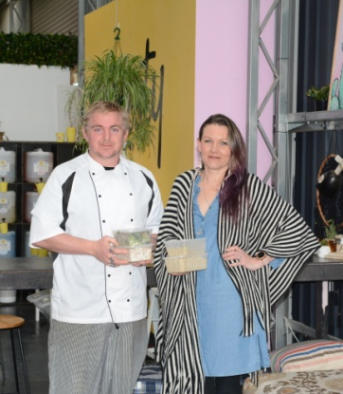
Under the Civil Liberties Amendment Act, businesses donating food are protected from liability (Ronni Kahn from Oz Harvest lobbied government to have legislation changed back in 2005). Please ensure food has been prepared and handled within food safety guidelines and check your local state legislation for more information.

Thank you,
Lana, Anthony and the Volunteer FMB Team

